Edinburgh Southern Orienteering Club
Bulletin for schools, March 2018

For further information on any of these items, please contact schoolenquiries@esoc.org.uk
Come and Try It (CATI): Orienteering at Bonaly Park
Three orienteering clubs are active in and around Edinburgh – our club, Edinburgh Southern (ESOC), another Edinburgh club called Interlopers (INT), and the East Lothian club (ELO), which is active across East Lothian. Between us at this time of year we organise a local event every week in the local woodlands and parks and even around the streets.
For example, ESOC has an event coming up at Bonaly Park, just beyond the Scout Camp on Saturday 16th June (https://www.esoc.org.uk/events/bonaly-park-jun-16-2018). Bonaly Park provides an exciting taste of orienteering, with woodlands (white on the map), open hillsides (yellow) and a good path network.
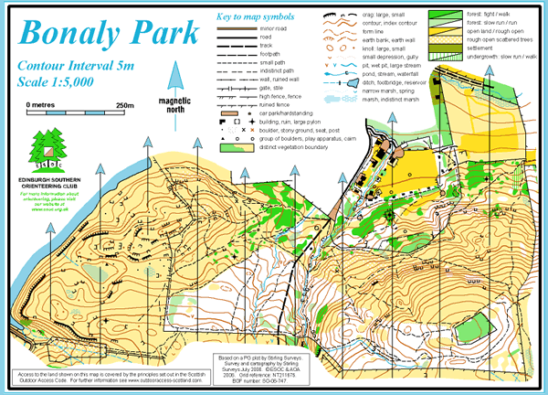
In addition there are local events in the near future on Saturday 28th April at Gosford Park near Aberlady (http://www.elo.org.uk/), and on Wednesday 2nd May (evening: no frills) in Haddington (http://www.elo.org.uk/2018/sprintelope-haddington/). All local events are listed on our website at https://www.esoc.org.uk/events.
Local events are what we call CATIs. They are easily-accessed events for beginners or club members who only want to orienteer locally, or more experienced orienteers who want to do some training. There will be coaches on hand at these events to explain how to take part and give advice on how to orienteer. They cost a few pounds to buy a map and make use of the electronic system for registering at control points around your course.
Orienteering at P6 & 7 & S1

Without doubt, P6 & 7 and S1 is the stage at which orienteering is most appreciated by school pupils. Pupils quickly grasp the concepts at this age and progress rapidly to the stage at which they can participate or compete on their own or in pairs at a local event.
At P6 & 7 orienteering also maps onto the CfE Experiences and Outcomes in Health and Wellbeing, Numeracy and Mathematics and Social Studies.

Orienteering at Outdoor Centres

Orienteering is one of the most popular activity choices at the City of Edinburgh outdoor centres, Benmore Centre in Argyll and Lagganlia in the Cairngorms National Park. Both centres are set in the countryside with super facilities for orienteering courses and other outdoor activities.
Visit https://www.youtube.com/watch?v=JsmZWuyc_tg for a video of orienteering in action at Benmore.

JASS take-up
More schools are asking ESOC to help them to include orienteering as the adventure component of the JASS Award
Typically, we would deliver practice sessions on the basics of orienteering in the gym and on the school playing field, with some orienteering games thrown in. Pupils are taken to the level at which they can complete a White course (the introductory course available at all orienteering events). Finally, there is a session in school to review what has been learnt and to reflect on the experience.

IntrO – a new course for teachers
The Scottish Orienteering Association has launched an exciting new course for teachers who would like to introduce orienteering in their school. This course is called IntrO and details are available at:
https://www.scottish-orienteering.org/soa/page/introducing-orienteering-new-course-for-teachers
The course is an active learning experience, with plenty of practical examples and suggestions for links to the experiences and outcomes of the CfE.
Roger Scrutton at schoolenquiries@esoc.org.uk would be happy to arrange mentoring support for teachers who have taken this course and want to get started back in school.

